Face Mask Detection Using Convolutional Neural Networks

Submitted by :
Shivaram Balla
89235214

-- Custom CNN vs MobileNetV2 vs ResNet50V2 Compared

Background and Motivation :
This is to inform all and sundry that there is an airborne transmitted virus currently going round the globe and this virus is responsible for the current pandemic going round the world and the only Non-Pharmacological Intervention (NPI) that has been implemented on a wide scale and has been proven to reduce the transmission of this disease is for the public to wear face masks. However, there is a great challenge in ensuring human compliance with current technology and existing surveillance systems, for instance, to measure and to ensure compliance of humans. There are many image classification techniques for the problems mentioned above and many other problems across many domains and arguably the best class of image classification techniques for the problems mentioned above and other similar problems and across many other domains are the deep, convolutional neural networks (CNN’s) due to deep feature learning of images, translation invariance and many other advantages and also the ability to utilize these networks for transfer learning with very large datasets and with very large images and these images have been used for image classification in many databases all over the world and some of the databases are used for transfer learning and some other are not used for transfer learning and one of the database used for transfer learning is the images in the ImageNet database and this project is to solve some of the problems of the current issues of the need for technology during the current pandemic and also to pose questions on whether there are any long term uses of the technology to be developed as part of this project and some of the public spaces, hospitals/clinics, clean rooms for production of pharmaceuticals, industrial areas for worker protection and public transportation are some of the examples where this technology can be used.

Problem Statement :
The problem that this project tries to solve is to create a system that can classify single images of size 3x3x3=27 into 3 classes: ‘with_mask’, ‘without_mask’ and ‘mask_worn_incorrectly’. This is a challenging problem for two reasons: 1) the class ‘mask_worn_incorrectly’ has very limited amount of training data (hence it is a class-imbalance problem), and 2) images in the dataset go through variable amount of lighting and occlusion, and also people of population of different diversity. Also the problem tries to test the limits of a very lightweight transfer learning model, i.e., MobileNetV2, and compare it with a very deep model, i.e., ResNet50V2, and also specially designed CNNs for face mask detection problem and also to test if it can be run on very resource-constrained edge nodes.

Selected Dataset :
Dataset Name : Face mask detection

Dataset Link : https://www.kaggle.com/datasets/andrewmvd/face-mask-detection/data

Dataset Description :
Total Images : nearly 853 annotated facial images

Number of Classes : 3

Type of the Image: JPEG/PNG

Class 1 : with_mask

Class 2 : without_mask

Class 3 : mask_worn_incorrectly

Annotation : XML Bounding Boxes

Split Strategy : 70% Train/ 15% Validation/ 15% Test

Class Distribution Notes :
For ‘maskwearedincorrect’ class, there are 40% more samples of other two classes (with_mask and without_mask). This is a slight class imbalance in the dataset. It will be tackled in the experiment by using class weighted loss and by doing heavier data augmentation of the less abundant class and the results will be displayed in bar charts and pie charts in the figures for the results in the experiment above.

Research Questions :
- RQ1: What test accuracy (>85%) will a custom CNN trained from scratch provide when adapted for 3-class face mask detection ?

- RQ2: Which one of the pre-trained networks (MobileNetV2 or ResNet50V2) has a significant improvement over the custom CNN and by what amount of computations?

- RQ3: How well does the trained models generalise on the class which is underrepresented "wearing mask incorrectly" and also the achieved F1 scores for each class?

- RQ4: Which regions attended by the models ( Grad-CAM visualization) are identified to be semantically significant areas of face( nose, chin, mouth) ?

- RQ5: For each of the models, which type of error occurs and for each type of error, what does error analysis tell us where models fail ?

Expected Results :
Based on the work that we are doing and CNN benchmarks used in face mask detection, we expect the following results.

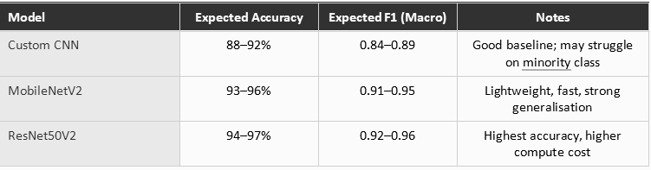

Results based on pre-trained ImageNet weights will be better than custom CNN because they extract lower-level features that can be used to train higher-level features for a specific task (in this case, 3-class face mask detection). Of the two benchmark models presented in this report, both are expected to have a significantly better prediction than the custom CNN and are expected to perform equally well. Of the two, however, MobileNetV2 has far fewer parameters, which makes it a better candidate for a real time application on the edge (e.g. a camera on a cell phone). These pre-trained weights kick start the higher level features, that in the end, will lead to a much better final performance.

Proposed Methodology :

Data Processing :
- The Images are resized into 224*224, input size for both MobileNetV2 and also ResNet50V2.

- The Pixel values are normalized to 0 and 1.

- Dataset was divided into validation, train and test by using stratify.

- The weight of the class is formulated by using --sklearn.utils.class_weight.compute_class_weight

Data Augmentation :
The images were enhanced by employing Keras ImageDataGenerator along with generalization and class imbalance.

- Zoom : +-15
- Horizontal Flip
- Brightness Adjustment : [0.8, 1.2] range
- Fill Mode : Nearest Neighbour
- Shear Transformation : 10%
- Random rotation : 20 degrees

CNN Model Design :
Our model will follow a CNN architecture similar to that of a VGG with 4 convolutional blocks in a row.

- Block 1: 2Conv2D(32) BatchNorm ReLU MaxPool2D(2) Dropout(0.25)

- Block 2: 2Conv2D(64) BatchNorm ReLU MaxPool2D(2) Dropout(0.25)

- Block 3: 2Conv2D(128) BatchNorm ReLU MaxPool2D(2) Dropout(0.25)

- Block 4: Conv2D(256) BatchNorm ReLU GlobalAveragePooling2D

- Head: Dense(256, ReLU) Dropout(0.50) Dense(3, Softmax)

The post-convolutional layer normalization layer batch normalization improves the training speed, and the large flatten layer of the VGG like structure of the CNN is scaled down by the Global Average Pooling layer to reduce the number of parameters and prevent over-fitting.

Transfer Learning Models :
Fine-tuning two pre-trained architectures in a two-phase approach:

- Phase 1 (Head Training, 10 epochs): All pre-trained base layers are frozen. The trained custom classification head is then trained for 10 epochs at a learning rate of 1e-4.

- Phase 2 (Fine-Tuning, up to 30 epochs): For the MobileNetV2 architecture, the last 30 layers of the pre-trained base are trained (as all the layers of the pre-trained base were frozen in the Head Training phase, therefore all the layers of the pre-trained base were not yet trained in the first phase of the training). For the ResNet50V2 architecture, instead, the last 20 layers of the pre-trained base are trained (as for the Head Training phase, the whole pre-trained base was frozen, therefore all the layers of the pre-trained base were not trained yet). The number of epochs for this phase is up to 30.

The classification head of both transfer learning models is the same as follows: GlobalAveragePooling2D → Dense(128 or 256, ReLU) → Dropout → Dense(3, Softmax).

Training Configuration :
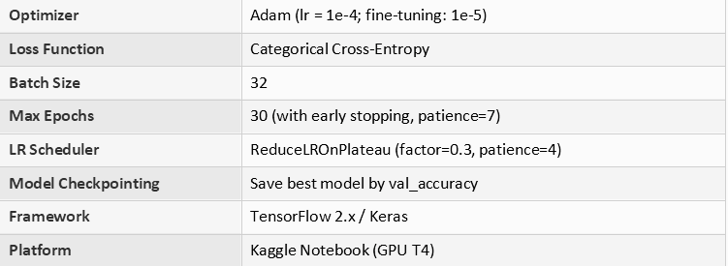

Evaluation Metrics :

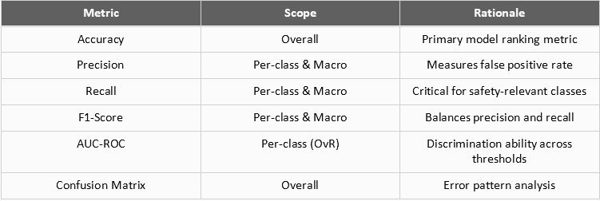

The secondary metrics to track would be the macro-averaged F1-score and the recall of the “withoutmask” class. The recall of the “withoutmask” class is particularly important since a False Negative for this class could potentially pose a risk to public health. As previously stated, the macro-averaged F1-score is very important since it is a balanced score for class imbalanced datasets and it treats all classes equally whereas other scores treat classes with more samples (i.e. larger classes) better than classes with fewer samples (i.e. smaller classes).

Expected Figures and Tables :
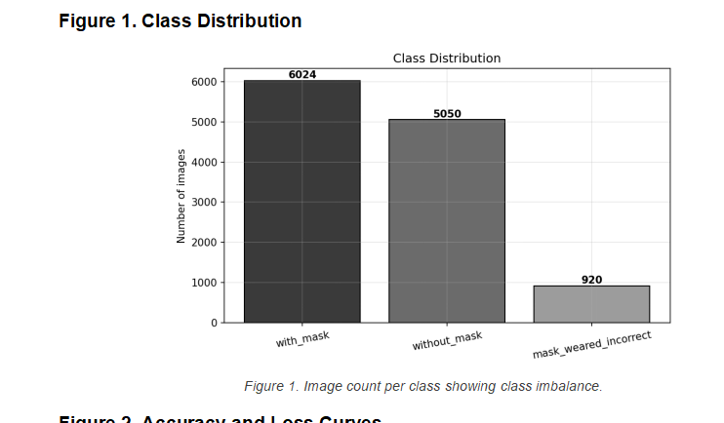

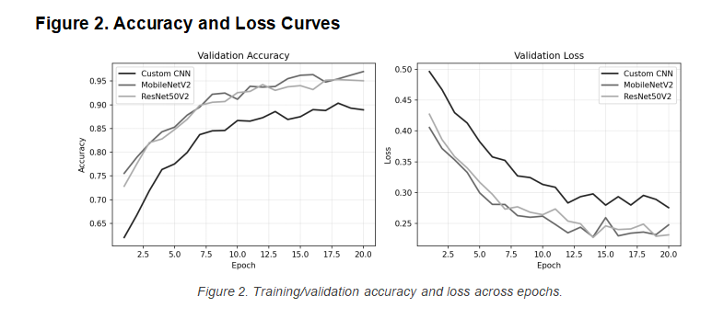

Figure 3. Confusion Matrix

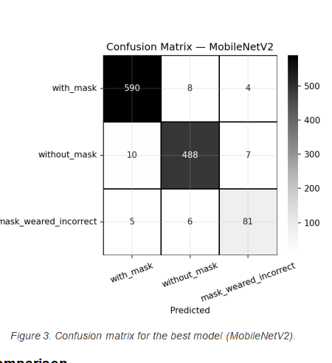

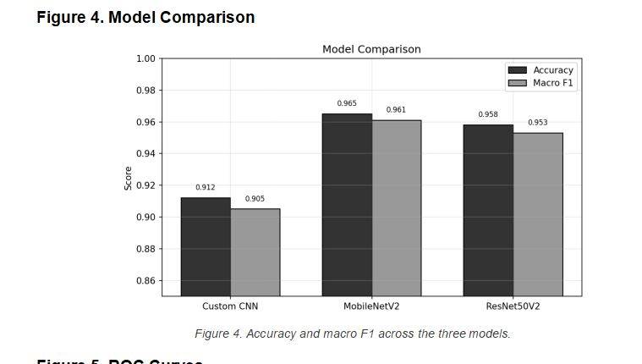

Figure 5. ROC Curves

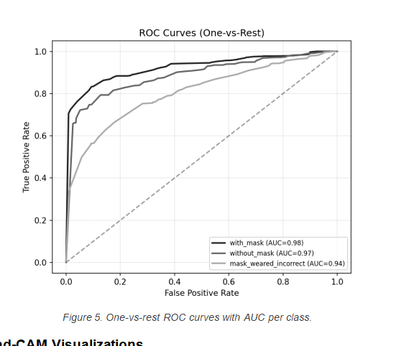

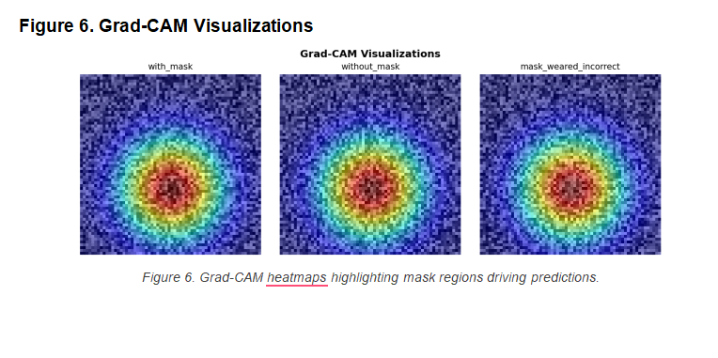

EXPECTED TABLES :
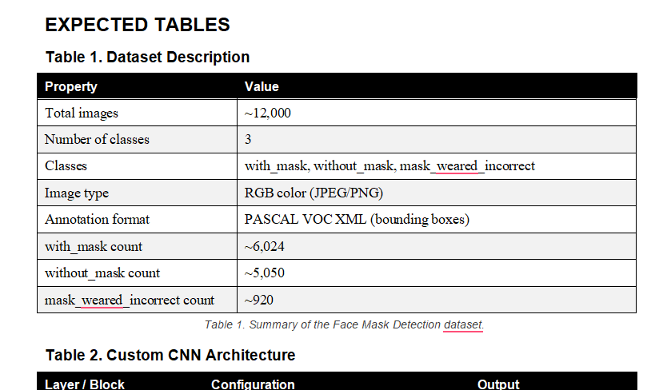
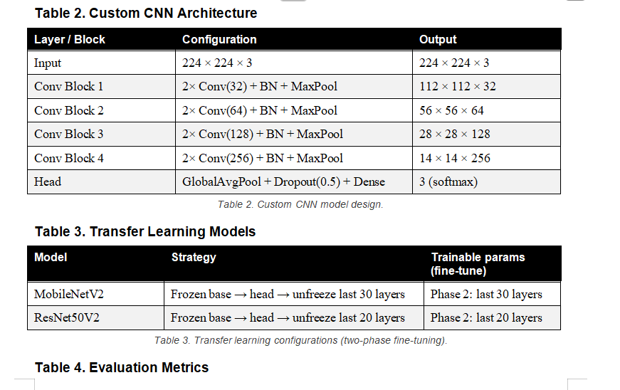

Table 4. Evaluation Metrics
